WEEKLY REFLECTION #2
Directions:
- This week you should have completed Box #3 and #4 of your 30-Day Fitness Challenge.
- Answer the questions below and submit your reflection in the "edit response" box. Be sure to hit "save" before you submit! Use complete sentences and correct capitalization and punctuation in all responses. You will lose 10 points if you don't do this.

Questions:
1. What challenge are you doing? (Remind me - I'm forgetful)
2. This week we learned about the Components of Fitness. Which component of fitness is your 30-day challenge? How do you know?
3. How were the workouts this week? Were they easy, challenging, or somewhere in between? If you had to rank how hard you worked using the RPE scale in the picture below, which would it be and why?
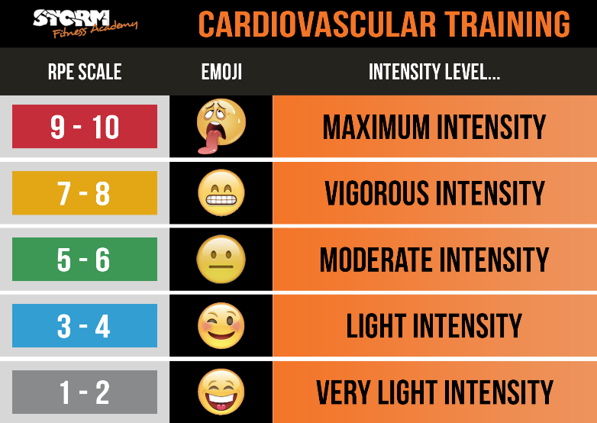
4. What is one specific goal you have for next week? This can be personal or academic.

