Cap. 1B – 11 de noviembre

**Caliente la mente:** Match the personality traits with activities

1. artístico A. practicar deportes
2. deportista B. dibujar y pintar
3. reservado C. pasar tiempo solo más que pasar tiempo con amigos
4. perezoso D. estudiar por muchas horas
5. trabajadora E. jugar videojuegos por 24 horas y nada más

**Escuchar – Act. 5: Buenos amigos**

|  |  |  |  |  |  |  |
| --- | --- | --- | --- | --- | --- | --- |
|  | Carmen | Pablo | Ana | Andrés | Raquel | Jorge |
| serio/a |  |  |  |  |  |  |
| reservado/a |  |  |  |  |  |  |
| deportista |  |  |  |  |  |  |
| estudioso/a |  |  |  |  |  |  |
| talentoso/a |  |  |  |  |  |  |
| gracioso/a |  |  |  |  |  |  |
| atrevido/a |  |  |  |  |  |  |
| trabajador/a |  |  |  |  |  |  |
| artístico/a |  |  |  |  |  |  |
| sociable |  |  |  |  |  |  |
| romántico/a |  |  |  |  |  |  |

***Buenos amigos:***

1. ______________________ y ______________________
2. ______________________ y ______________________
3. ______________________ y ______________________

**Hablar**: Ask your partner the questions below. Jot down the adjectives and activities they tell you.

1. ¿Cómo eres?
2. ¿Cómo no eres?
3. ¿Qué te gusta hacer?
4. ¿Qué no te gusta hacer?

**TAREA**

**Parte 1**

Use the answers your partner gave you in in the Hablar exercise to write about your partner.

Tell me what he/she is (not) like and what he/she likes and doesn’t like to do.

______________________________________________________________________________________________________________________________________________________________________________________________________________________________________________________________________________

**Parte 2**

Fill in the words using the art as clues. Make sure the gender of the adjective matches the gender of the person in the picture.

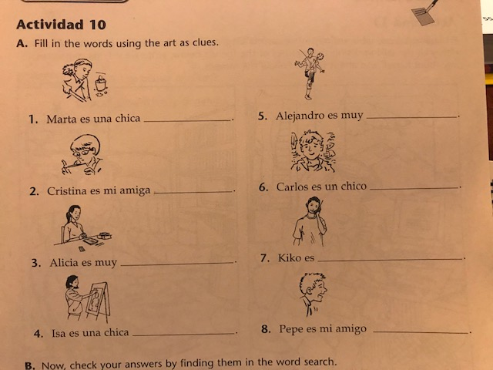

**Don’t forget: Vocab quiz is tomorrow! What to know:**

* **adjectives**
* **activities**
* **¿Cómo (no) eres?**
* **¿Qué (no) te gusta hacer?**