Capítulo 1B: Y tú, ¿cómo eres?

9 de noviembre

**Práctica #1: Vocabulario en contexto**

1. Name:

Relationship to Coach Mack:

Personality traits:

Activity:

1. Name:

Relationship to Coach Mack:

Personality traits:

Activities:

1. Name:

Relationship to Coach Mack:

Personality traits:

Activities:

**Práctica #2: ¿Cómo es el chico o la chica?**

Follow the directions in the picture. Select the vocab term represented in the picture. Then write it on the line.

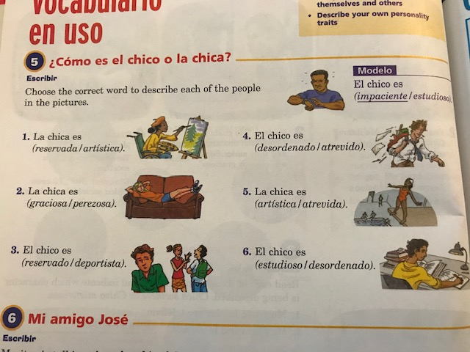

1. _________________________________
2. _________________________________
3. _________________________________
4. _________________________________
5. _________________________________
6. _________________________________

**Práctica #3: Mi amigo José**

Maritza is talking about her friend José. Read the sentences, then choose the appropriate word to fill in each blank.

Word bank: trabajador deportista bueno paciente

estudioso sociable gracioso desordenado

1. Le gusta mucho practicar deportes. Es ___________________________.
2. A veces no es serio. Es un chico ________________________________.
3. Le gusta pasar tiempo con amigos. Es muy _________________________.
4. No es un chico ordenado. Es ____________________________.
5. Le gusta ir a la escuela. Es ___________________________________.
6. No es perezoso. Es un chico muy ______________________________.
7. Es simpático. Es un amigo muy ______________________________.

**Práctica #4: ¿Eres…?**

Ask your partner the questions below. Write down the adjectives they use to describe themselves. Then write about your partner in 2-3 sentences using the information you collected.

1. ¿Cómo eres? (2 adj)

_______________________________________________________________________________________________________________________________________________________________________________________

1. ¿Cómo no eres? (1 adj)

**Tarea:**

Parte 1 - At school you may see different types of people. Describe each person you see in the picture by writing the appropriate adjective on the line. Remember, the gender of the adjective should match the person.

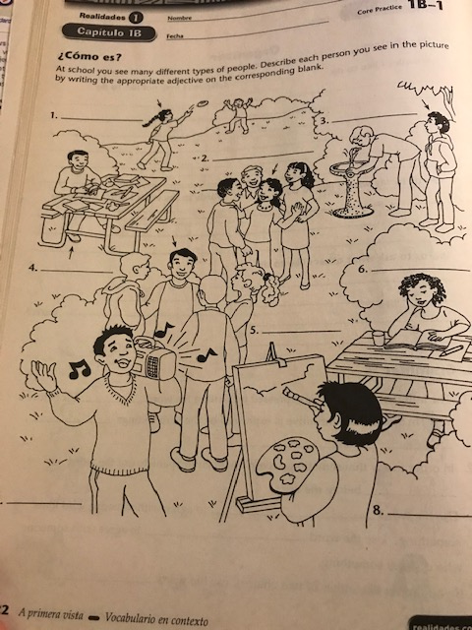

1. _________________________________
2. _________________________________
3. _________________________________
4. _________________________________
5. _________________________________
6. _________________________________
7. _________________________________
8. _________________________________

Parte 2 – Based on the descriptions below, tell me what each person is like. Follow the model below.

Modelo: Ana le gusta trabajar. Ana es trabajadora.

1. Enrique le gusta tocar un instrumento.

2. Teresa le gusta pasar tiempo con amigos.

3. Te gusta practicar deportes.

4. Me gusta dibujar.